
Ray of Hope for Children of Tanzania
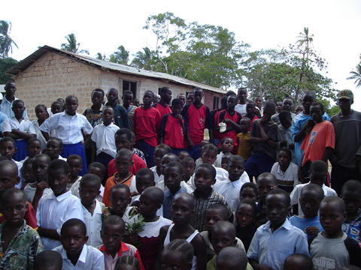
In collaboration with the International Institute for Peace through Tourism (IIPT), Lions Club of Dar es Salaam City (Lions), and Miracle Corners of the World (MCW), the IIPT Student/Youth Network is proposing a service project to give back to the future of a magnificent country, Tanzania.

Tanzania

Tanzania is a developing country located in the east central part of Africa, covering a total area of 364,899 sq. miles with a population of 36 million. Even though the country seems big enough to hold these many people, Tanzania lacks the social services to support its population. An average employed individual in the capital city of Dar es Salaam earns less than $1 a day; people in rural areas earn even less.
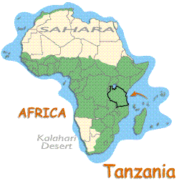

Purpose
This service project aims to raise sufficient funds to provide a better quality of life for the children of elementary schools in the outskirts of Dar es Salaam. The children’s quality of life can be improved by supplying a good living environment, preventive health care, and other essentials to make each growing individual a better citizen.

Overview
This project is directed toward helping the unfortunate children of Tanzania who struggle to have a daily meal. These children spend their childhood roaming the streets in search of food, clothing, and shelter. The situation is very severe; many children die each day due to malnutrition and diseases such as malaria, typhoid, and AIDS. Furthermore, Tanzania is experiencing a harsh drought. Thousands of people are dying of hunger, most of them children. These children need your help. It is our duty as the citizens of the world to give them hope and a reason to smile.

Objectives
- Help children of Kibada Primary School and indirectly promote peace and prosperity
- Provide an appropriate school facility that is conducive for learning
- Raise the children’s living standards by providing access to basic resources such as medical supplies, stationery, and vocational training
- Give back to our home community by helping the children to have a future rather than a life on the street
Plan
This service project is planned to start the summer of 2006. During the month of August, we are planning to help a small elementary school called Kibada Primary School. Kibada is located in the Kigamboni area, which is a part of the city of Dar es Salaam (separated from the rest of the city by the Kurasini Creek). Kibada has 560 students attending elementary school and approximately 30 children in kindergarten.

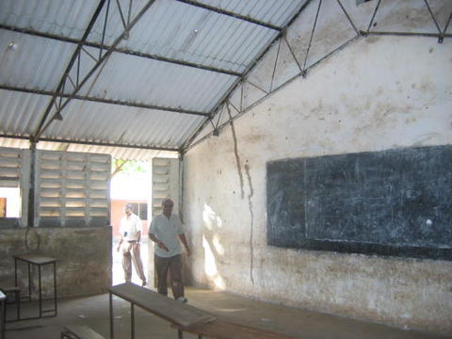
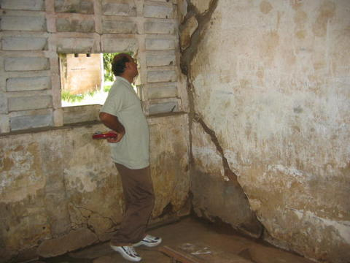

Classroom condition at Kibada Primary School Classroom condition at Kibada Primary School
IIPT will join forces with Lions Club and MCW organizations to provide resources and organize help for this small and needy school.
What activities will take place?
- Provide stationery, desks, blackboards, chalk, educational posters and other school supplies
- Provide clothing, mosquito nets, medical kits, and other miscellaneous items to Kibada Primary School
- Donate a desktop computer and printer to Kibada Primary School for administrative and learning purposes
- Donate basic necessities to a needy orphanage(s) in Dar es Salaam or Pwani area
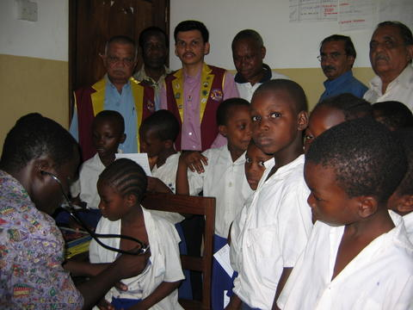
How many children will benefit?
The project is intended to benefit all 590 children at the Kibada Primary School. Funds raised will determine the number of projects we can complete.

Lions Club sponsored health check up for students

Budget for the Community Service project – Costs involved.
No. | Details | Unit cost ($) | Approx Total cost ($)
1 | Mosquito Nets – 30 units for the Kindergarten students at Kibada | 10 | 300
3 | School supplies (exercise books, textbooks, stationery, school bags, etc.) |  | 1000
4 | Painting classrooms and adding materials such as blackboards and posters. |  | 2000
5 | 65 desks for higher grades. | 30 | 1950
6 | Basic necessities (medical supplies, sanitized materials) |  | 500
7 | Donation of desktop computer |  | 500
 | * TOTAL (U.S. $) |  | 6250
* - Total number of donations to the school will exclusively depend upon the donations received and will be apportioned according to the project requirements.


Collaborators for the Service Project
International Institute for Peace through Tourism (IIPT) - The International Institute for Peace through Tourism (IIPT) is a not for profit organization dedicated to fostering travel and tourism initiatives that contribute to international understanding and cooperation, an improved quality of environment, the preservation of heritage, and poverty reduction; and through these initiatives, helping to bring about a peaceful and sustainable world. It is founded on a vision of the world’s largest industry, travel and tourism – becoming the world’s first global peace industry; and the belief that every traveler is potentially an “Ambassador for Peace.” For more information visit http://www.iipt.org

Miracles Corner of the World - MCW works closely with community members and leaders, educational institutions, governmental agencies and not-for-profit organizations on a global basis to develop programs that advance cross-cultural understanding and promote sustainable improvements in the education, healthcare and economic well-being of socio-economically diverse communities through youth empowerment and leadership development. For more information visit: http://www.miraclecorners.org


Lions Club of Dar-es-Salaam City - Since 1917, Lions clubs have offered people the opportunity to give something back to their communities. From involving members in local projects such as cleaning up a park or as far-reaching as bringing sight to the world's blind, Lions clubs have always embraced those committed to building a brighter future for their community. Today with more than approximately 45,000 clubs in 197 countries and geographical areas, Lions have expanded their focus to help meet the ever increasing needs of our global community. For more information visit: http://www.lionsclubs.org

What Can You Do?
Consider donating towards this much needed project. Upon our return we will bring back pictures for you to see how your donations directly affected the children of Tanzania Donations can be made by cash or check and are tax deductible. Please make your checks payable to:

International Institute for Peace Through Tourism
685 Cottage Club Road, Unit 13, Stowe, VT 05672
Tel: +1 802 253 2658 • Fax: +1 802 253 2645

Your generous donation will truly bring smiles to these young lives.

Please do not hesitate to contact us for any further details about the service project. You can reach us through e-mail: nishit@iipt.org or amani197@yahoo.com or give us a call at 612-226-6784.

May god bless you and May Peace Prevail on Earth.

Sincerely yours,

Nishit H. Charadva
IIPT Youth Coordinator

